**LAPORAN WORKSHOP PEMROGRAMAN DASAR**

**TUGAS TAKE HOME UAS SEMESTER 1**



Oleh :

Firman Wahyudi

E41190305

Teknik Informatika A

**JURUSAN TEKNOLOGI INFORMASI**

**POLITEKNIK NEGERI JEMBER**

**2019**

**TAKE HOME UAS**

1. **Script Frame**
2. **Index**

<!DOCTYPE html>

<html>

<head>

<meta http-equiv="Content-Type" content="text/html; charset=utf-8" />

<title>Tugas Take Home</title>

</head>

    <frameset rows="8.7%,*, 10%">

        <frame name="header" src="header.html" style="background-image:url('asa.png');"></frame>

        <frame name="isi" src="isi.html">

        <frame name="footer" src="footer.html" style="background-color:#F0F8FF"></frame>

    </frameset>

<body>

</body>

</html>

1. **Footer**

<!DOCTYPE html>

<html>

<head>

<title>footer</title>

</head>

<body>

     <center>

         <h3>ini footer</h3>

     </center>

</body>

</html>

1. **Header**

<!DOCTYPE html>

<html>

<head>

 <title>header</title>

 <link rel="stylesheet" type="text/css" href="node_modules/bootstrap/dist/css/bootstrap.css">

  <script type="text/javascript" src="node_modules/bootstrap/dist/js/bootstrap.js"></script>

  <script type="text/javascript" src="node_modules/bootstrap/js/src/jquery.js"></script>

  <script type="text/javascript" src="main.js"></script>

</head>

<body>

<nav class="navbar navbar-expand-lg navbar-light bg-light">

  <a class="navbar-brand" href="#">Web APP</a>

  <button class="navbar-toggler" type="button" data-toggle="collapse" data-target="#navbarNav" aria-controls="navbarNav" aria-expanded="false" aria-label="Toggle navigation">

    <span class="navbar-toggler-icon"></span>

  </button>

  <div class="collapse navbar-collapse" id="navbarNav">

    <ul class="navbar-nav">

      <li class="nav-item active">

        <a class="nav-link" href="isi.html" target="isi">Home <span class="sr-only">(current)</span></a>

      </li>

      <li class="nav-item active">

        <a class="nav-link" href="form.html" target="isi">Data Mahasiswa <span class="sr-only">(current)</span></a>

      </li>

      <li class="nav-item active">

        <a class="nav-link" href="tugas1.html" target="isi">Luas dan Keliling <span class="sr-only">(current)</span></a>

      </li>

      <li class="nav-item active">

        <a class="nav-link" href="while_nilai.html" target="isi">Data Nilai <span class="sr-only">(current)</span></a>

      </li>

      <li class="nav-item active">

        <a class="nav-link" href="tugas2.html" target="isi">UTS <span class="sr-only">(current)</span></a>

      </li>

    </ul>

  </div>

</nav>

</body>

</html>

1. **Isi**

<!DOCTYPE html>

<html>

<head>

    <title>Isi</title>

    <style type="text/css">

        body {

            background-image: url(asa.png);

        }

        h2,h3,h4,p{

            text-align: center;

            color: black;

        }

    </style>

</head>

<body>

    <h2>Biodata Diri</h2>

    <h4>NIM : E41190305</h4>

    <h4>Nama : Firman Wahyudi</h4>

    <h4>Prodi : Teknik Informatika</h4>

    <h4>Jurusan : Teknologi Informasi</h4>

</body>

</html>

**Screenshot :**

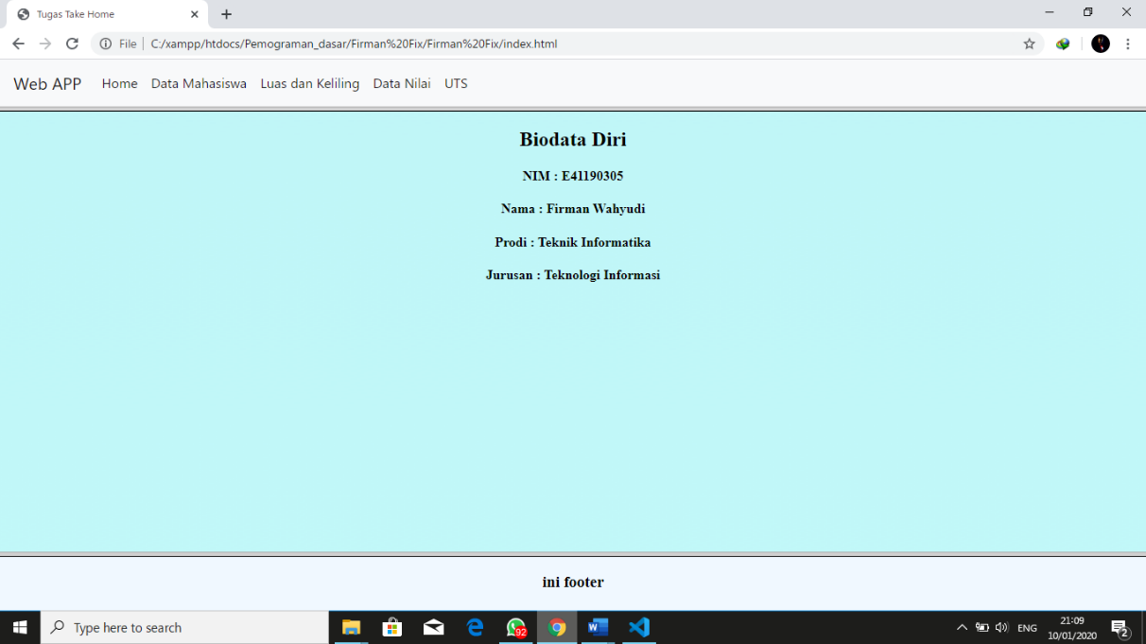

1. **Tugas 1 (luas dan keliling)**

<html>

<head>

    <title> TUGAS </title>

</head>

<body style="background-image: url(asa.png);">

</body>

<script>

    var panjang = 10;

    var lebar = 8;

    var luas = panjang * lebar;

    var keliling = (2 * panjang) + (2 * lebar);

    document.write("Hasil Luas Persegi Panjang adalah "+luas);

    document.write("<br>Hasil Keliling Persegi Panjang adalah "+keliling);

</script>

</html>

**Screenshot :**

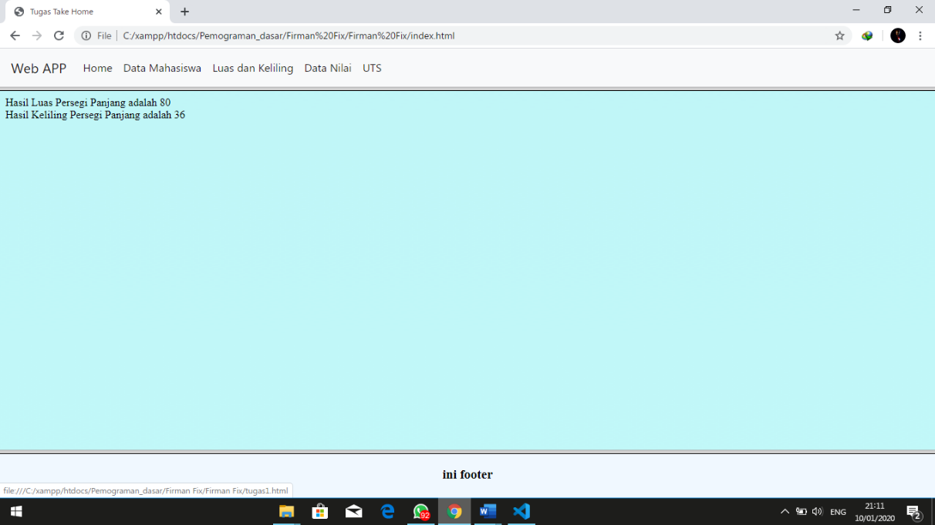

1. **Tugas 2 (Input Nilai)**

<!DOCTYPE html>

<html>

<head>

<title>Nilai</title>

<style type="text/css">

table, td, th {

border: 3px solid black;

text-align: center;

color: black;

}

table {

border-collapse: collapse;

width: 100%;

}

th, td {

padding: 15px;

}

h3{

text-align: center;

color: black;

}

</style>

</head>

<body style="background-image: url(asa.png);">

<script type="text/javascript">

var nim = prompt("Masukkan NIM :");

var nama = prompt("Masukkan Nama : ");

document.write("<h3>NIM : "+nim+"</h3>");

document.write("<h3>Nama : "+nama+"</h3>");

var loop = prompt("Masukkan Jumlah Nilai : ");

loop = eval(loop)

var i = 1; var huruf = "";

document.write("<table border='1' align='center'>");

document.write("<tr>");

document.write("<th>Nilai Ke</th>");

document.write("<th>Nilai</th>");

document.write("<th>Huruf</th>");

document.write("</tr>")

while(i <= loop){

var nilai = prompt("Masukkan Nilai Ke "+i+" :");

nilai = eval(nilai);

if (nilai >= 90 && nilai <= 100) {

huruf = "A";

}else if (nilai >= 80 && nilai <= 89) {

huruf = "B";

}else if (nilai >= 60 && nilai <= 79) {

huruf = "C";

}else if (nilai >= 50 && nilai <= 59) {

huruf = "D";

}else if (nilai >= 0 && nilai <= 49) {

huruf = "E";

}

document.write("<tr>");

document.write("<td>"+i+"</td>");

document.write("<td>"+nilai+"</td>");

document.write("<td>"+huruf+"</td>");

document.write("</tr>")

i++

}

document.write("</table>");

</script>

</body>

</html>

**Screenshot :**

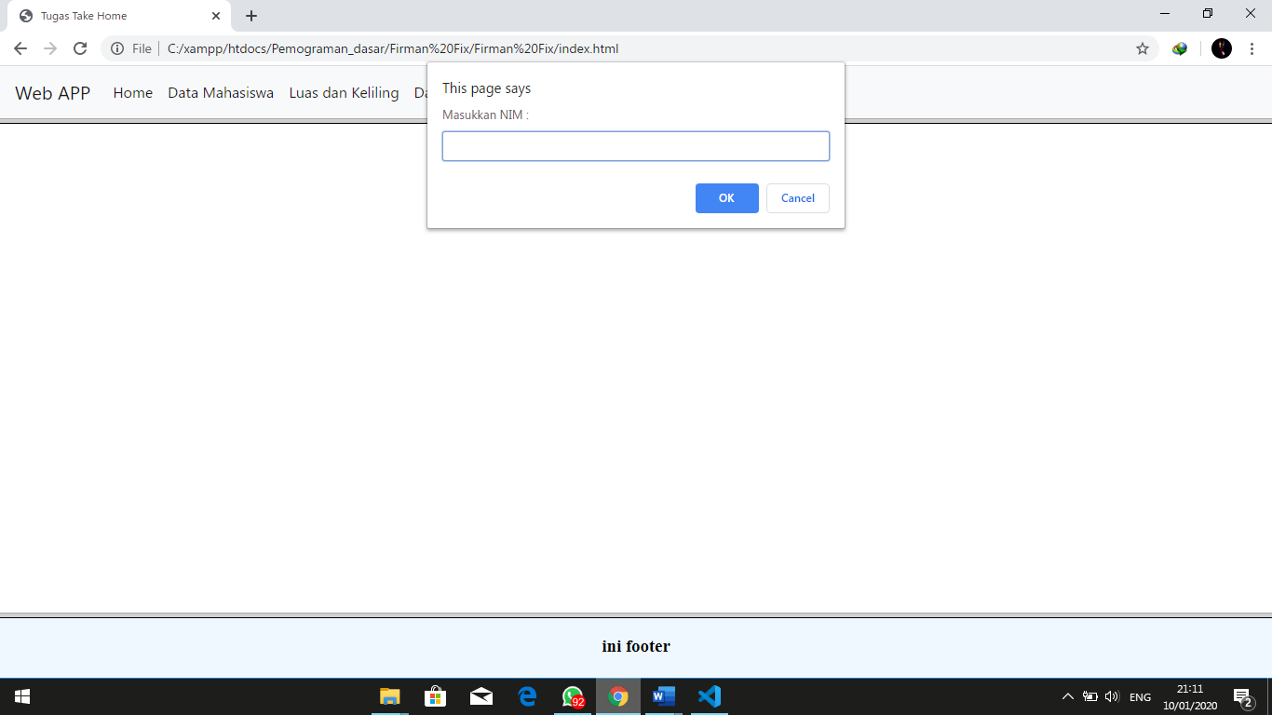

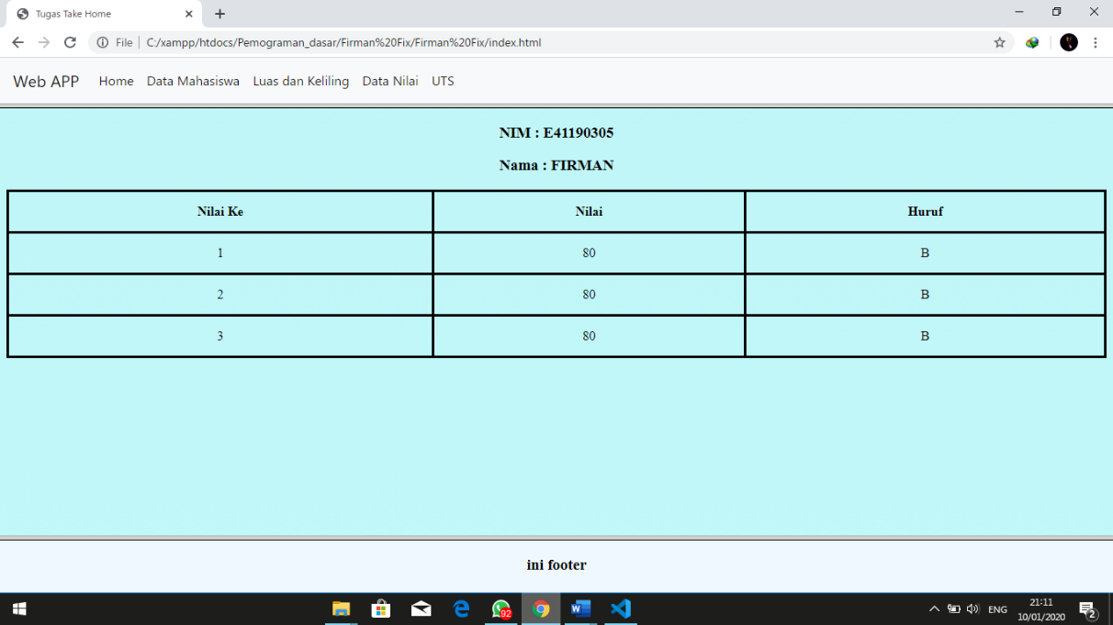

1. **Tugas 3 (Data Mahasiswa)**

<!DOCTYPE html>

<html>

<head>

    <title>Form With Bootstrap</title>

    <link rel="stylesheet" type="text/css" href="node_modules/bootstrap/dist/css/bootstrap.css">

    <script type="text/javascript" src="node_modules/bootstrap/dist/js/bootstrap.js"></script>

    <script type="text/javascript" src="node_modules/bootstrap/js/src/jquery.js"></script>

    <script type="text/javascript" src="main.js"></script>

    <style type="text/css">

        body {

            background-image: url(asa.png);

        }

    </style>

</head>

<body>

    <div class="container">

        <div class="col-sm-12">

            <hr  align="center" color="#6495ED">

            <center><h2>Data Mahasiswa</h2></center>

            <hr align="center" color="#6495ED">

            <form name="form">

                <div class="form-group row">

                    <label class="col-sm-2 col-form-label">NIM</label>

                    <div class="col-sm-7">

                        <input type="text" name="nim" class="form-control">

                    </div>

                </div>

                <div class="form-group row">

                    <label class="col-sm-2 col-form-label">Nama</label>

                    <div class="col-sm-7">

                        <input type="text" name="nama" class="form-control">

                    </div>

                </div>

                <div class="form-group row">

                    <label class="col-sm-2 col-form-label">Jenis Kelamin</label>

                    <div class="col-sm-7">

                        <div class="form-check">

                            <input type="radio" name="jk" class="form-check-input" value="Pria">

                            <label class="form-check-label">Pria</label>

                        </div>

                        <div class="form-check">

                            <input type="radio" name="jk" class="form-check-input" value="Wanita">

                            <label class="form-check-label">Wanita</label>

                        </div>

                    </div>

                </div>

                <div class="form-group row">

                    <label class="col-sm-2 col-form-label">Agama</label>

                    <div class="col-sm-7">

                        <select name="agama" class="form-control">

                            <option value="Silahkan Pilih Agama">Silahkan Pilih Agama</option>

                            <option value="Islam">Islam</option>

                            <option value="Kristen">Kristen</option>

                            <option value="Hindu">Hindu</option>

                            <option value="Budha">Budha</option>

                            <option value="Khonghucu">Khonghucu</option>

                        </select>

                    </div>

                </div>

                <div class="form-group row">

                    <label class="col-sm-2 col-form-label">Status</label>

                    <div class="col-sm-7">

                        <div class="form-check">

                            <input type="checkbox" name="BelumMenikah" class="form-check-input">

                            <label class="form-check-label">Belum Menikah</label>

                        </div>

                        <div class="form-check">

                            <input type="checkbox" name="Menikah" class="form-check-input">

                            <label class="form-check-label">Menikah</label>

                        </div>

                    </div>

                </div>

                <div class="form-group row">

                    <label class="col-sm-2 col-form-label">Progam Studi</label>

                    <div class="col-sm-7">

                        <div class="form-check">

                            <input type="checkbox" name="TIF" class="form-check-input">

                            <label class="form-check-label">TIF</label>

                        </div>

                        <div class="form-check">

                            <input type="checkbox" name="TKK" class="form-check-input">

                            <label class="form-check-label">TKK</label>

                        </div>

                        <div class="form-check">

                            <input type="checkbox" name="MIF" class="form-check-input">

                            <label class="form-check-label">MIF</label>

                        </div>

                    </div>

                </div>

                <div class="form-group row">

                    <label class="col-sm-2 col-form-label">Essay</label>

                    <div class="col-sm-7">

                        <textarea class="form-control" name="essay"></textarea>

                    </div>

                </div>

                <div class="form-group">

                    <button type="button" class="btn btn-outline-primary" onclick="tampilkan()">Tampilkan Data</button>

                    <button type="reset" class="btn btn-outline-danger">Reset</button>

                </div>

                <hr align="center" color="#6495ED">

                <center><h2>Hasil Data</h2></center>

                <hr align="center" color="#6495ED">

                <div class="form-group row">

                    <label class="col-sm-2 col-form-label">NIM</label>

                    <div class="col-sm-7">

                        <input type="text" name="nimout" class="form-control">

                    </div>

                </div>

                <div class="form-group row">

                    <label class="col-sm-2 col-form-label">Nama</label>

                    <div class="col-sm-7">

                        <input type="text" name="namaout" class="form-control">

                    </div>

                </div>

                <div class="form-group row">

                    <label class="col-sm-2 col-form-label">Jenis Kelamin</label>

                    <div class="col-sm-7">

                        <input type="text" name="jkout" class="form-control">

                    </div>

                </div>

                <div class="form-group row">

                    <label class="col-sm-2 col-form-label">Agama</label>

                    <div class="col-sm-7">

                        <input type="text" name="agamaout" class="form-control">

                    </div>

                </div>

                <div class="form-group row">

                    <label class="col-sm-2 col-form-label">Status</label>

                    <div class="col-sm-7">

                        <input type="text" name="statusout" class="form-control">

                    </div>

                </div>

                <div class="form-group row">

                    <label class="col-sm-2 col-form-label">Program Studi</label>

                    <div class="col-sm-7">

                        <input type="text" name="prodiout" class="form-control">

                    </div>

                </div>

                <div class="form-group row">

                    <label class="col-sm-2 col-form-label">Essay</label>

                    <div class="col-sm-7">

                        <textarea class="form-control" name="essayout"></textarea>

                    </div>

                </div>

                <hr align="center" color="#6495ED">

            </form>

        </div>

    </div>

</body>

</html>

**Screenshot :**

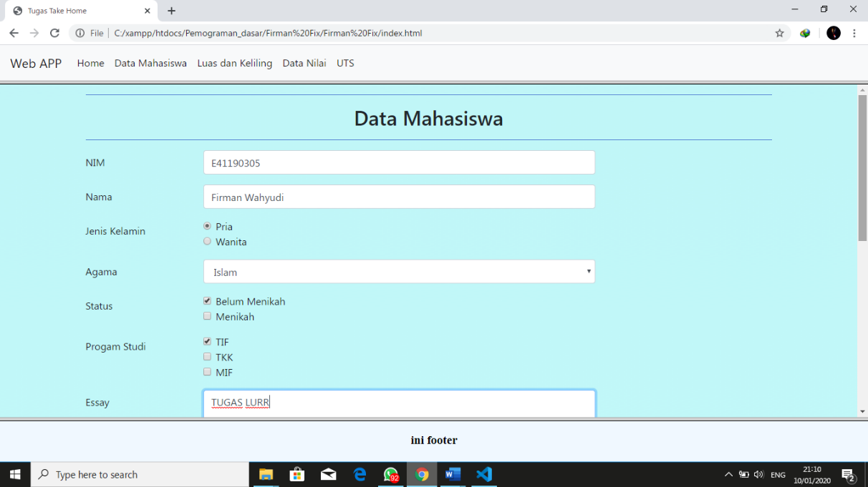

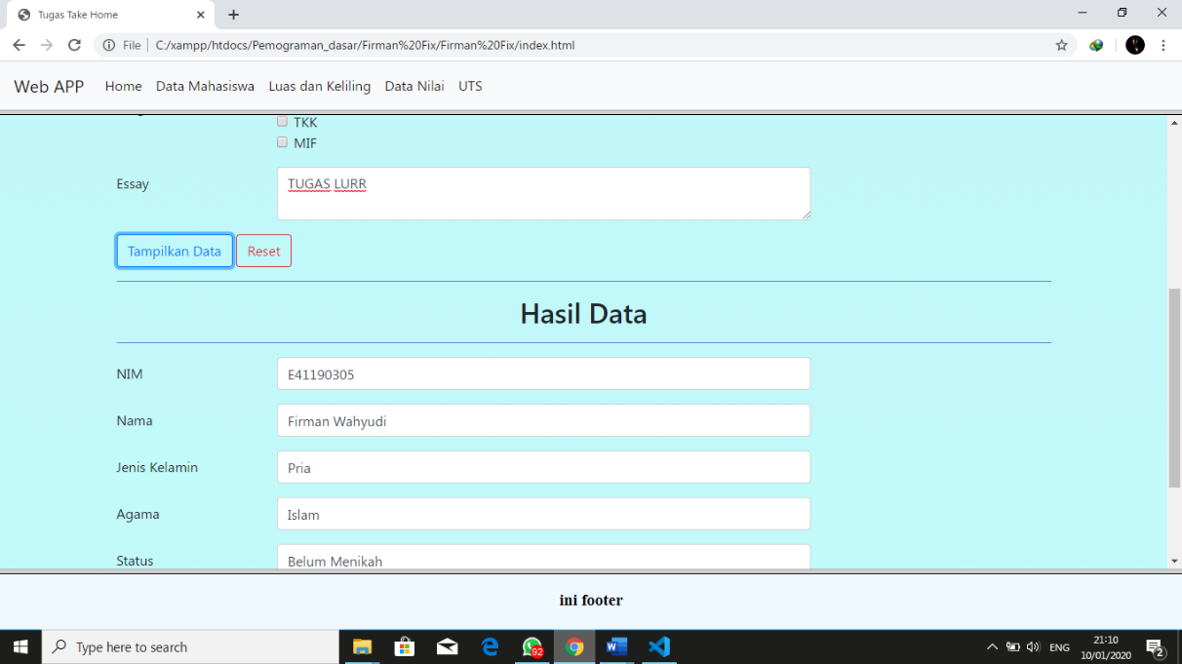

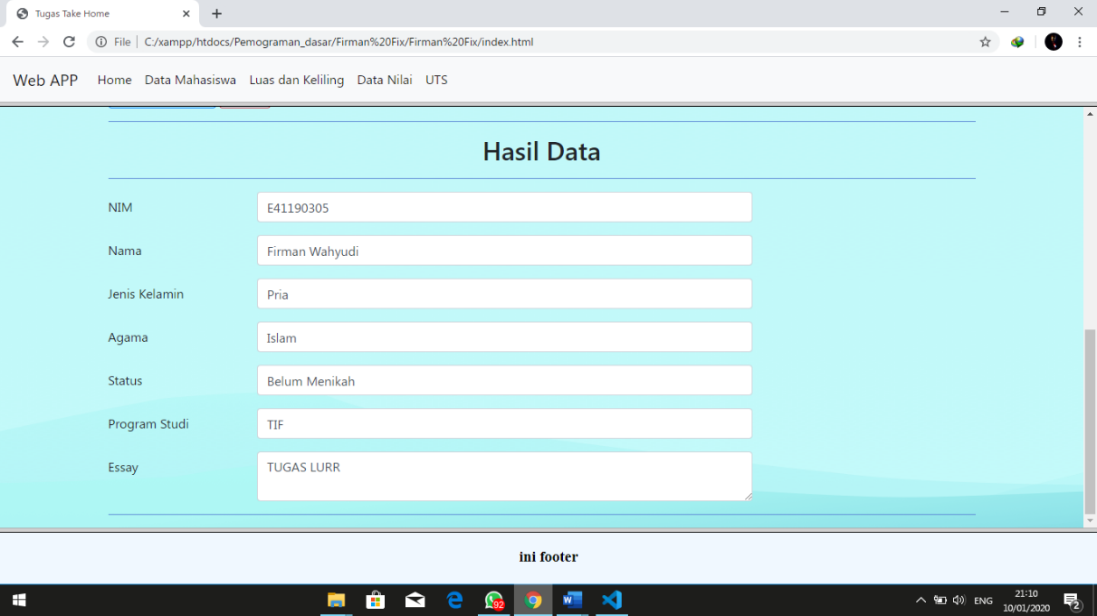

1. **Tugas UTS (Perulangan)**

<!DOCTYPE html>

<html>

<head>

    <title>Data Mahasiswa</title>

    <style type="text/css">

        h1{

            text-align : center;

            color: black;

            padding: 30px;

        }

        body{

            background-image: url(asa.png);

        }

        table, td, th {

            border: 3px solid black;

            text-align: center;

            color: black;

        }

        table {

            border-collapse: collapse;

            width: 100%;

        }

        th, td {

            padding: 15px;

        }

    </style>

</head>

<body>

    <h1>Data Mahasiswa</h1>

    <hr>

    <table border="1">

        <thead>

            <tr>

                <th>#</th>

                <th>Nim</th>

                <th>Nama</th>

                <th>Tugas 1</th>

                <th>Tugas 2</th>

                <th>UTS</th>

                <th>UAS</th>

                <th>Rata - Rata</th>

                <th>Huruf</th>

                <th>Status</th>

            </tr>

        </thead>

        <tbody id="isi">

            <script type="text/javascript">

                var jmlh = prompt("Masukkan Jumlah Siswa :")

                jmlh = eval(jmlh)

                for(i=1;i<=jmlh;i++){

                //Pengisian Data Mahasiswa

                var nim = prompt("Masukkan Nim :");

                var nama = prompt("Masukkan Nama :");

                var tgs_1 = prompt("Masukkan Nilai Tugas 1 :");

                tgs_1 = eval(tgs_1);

                var tgs_2 = prompt("Masukkan Nilai Tugas 2 :");

                tgs_2 = eval(tgs_2);

                var uts = prompt("Masukkan Nilai UTS :");

                uts = eval(uts);

                var uas = prompt("Masukkan Nilai UAS :");

                uas = eval(uas);

                //Perhitungan Rata Rata

                rata = (tgs_1+tgs_2+uts+uas)/4;

                //Pemberian Grade dan Status

                var status = "";

                var huruf = "";

                if (rata >= 85 && rata <= 100) {

                    huruf = "A";

                    status = "LULUS";

                }else if (rata >= 70 && rata <= 84) {

                    huruf = "B";

                    status = "LULUS";

                }else if (rata >=60 && rata <= 69) {

                    huruf = "C"

                    status = "Lulus"

                }else if (rata >= 50 && rata <= 59) {

                    huruf = "D"

                    status = "Tidak Lulus"

                }else if (rata >= 0 && rata <= 49) {

                    huruf = "E"

                    status = "Tidak Lulus"

                }else{

                    huruf = "Nilai Tidak Valid"

                    status = "Nilai Tidak Valid"

                }

                document.write("<tr>")

                document.write("<td>"+i+"</td>")

                document.write("<td>"+nim+"</td>")

                document.write("<td>"+nama+"</td>")

                document.write("<td>"+tgs_1+"</td>")

                document.write("<td>"+tgs_2+"</td>")

                document.write("<td>"+uts+"</td>")

                document.write("<td>"+uas+"</td>")

                document.write("<td>"+rata+"</td>")

                document.write("<td>"+huruf+"</td>")

                document.write("<td>"+status+"</td>")

                document.write("</tr>")

            }

        </script>

        </tbody>

    </table>

</body>

</html>

**Screenshot :**

